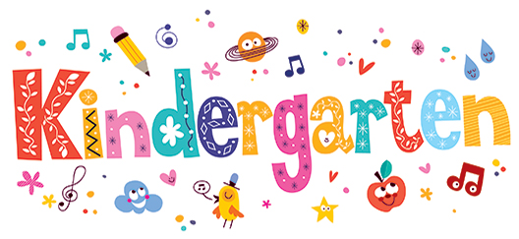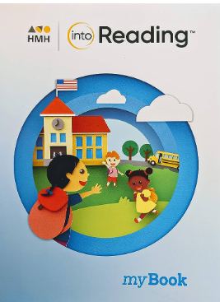

**At P.S.329**

**We are so excited to meet all of you! This will be an exciting year filled with lots of new friends, adventures, and learning.**

**Standard Based Curriculum:**

**READING:** HMH Into Reading

Our 1st unit, Curious About Kindergarten, This unit establishes routines and instructional practices that support the development of foundational reading skills.

Students read daily for a period of time (10 – 20 minutes).

**Read Aloud** – Students listen while the teacher reads aloud; strategies are modeled.

**Shared Reading** – Teacher and students interactively read a text together. Teacher guides and supports students as they read.

**Guided Reading** – Teacher works on a reading strategy with a small group, reading on the same reading level.

**Teachers College Writing: 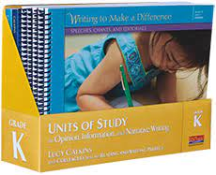Students will learn that they are brave writers. They can think of a topic, say what they want to write, and then write it! The big emphasis is on helping students to put themselves on the page, especially through drawing. We will establish many key writing routines.**

**\*Math:**  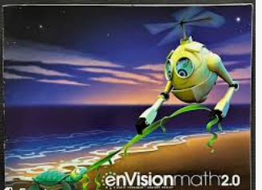Currently, students are learning how to read, count, and write numbers from 0-5. Students will use counters, drawings, and manipulatives during this topic.

**\*Amplify Science:**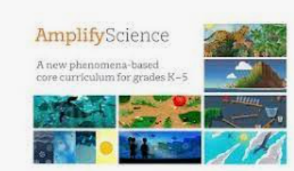Students engage in three-dimensional learning to solve real-world questions and problems. ***Topics include***: Needs of Plants and Animals: Milkweed and Monarchs, Pushes and Pulls: Designing a Pinball Machine, Sunlight and Weather: Solving Playground Problems, and Balancing Forces, Inheritance and Traits, Environments and Survival, Weather and Climate.

**\*Passport Social Studies:** 

***Topics include*** My School and School Community, Self and Others: Individual Development and Cultural Identity, Geography, People, and the Environment, and Families, Change, and Time.

***Our goal is for students to become lifelong readers, writers, and thinkers through exposure to authentic literature, active participation, and real-world situations.***

**Welcome to**